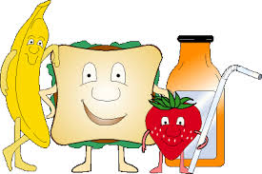
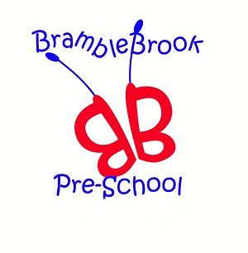
Dear Mums, Dads and Carers,

Healthy Eating Topic
This term the children have been learning all about healthy foods. We have been teaching this through circle time, playing games such as healthy food bingo, puzzles, making healthy snacks and visitors into Pre-school such as the Tesco Farm to Fork programme. The children have really enjoyed learning all about healthy foods and the ladies from Tesco were so impressed with their knowledge!
Our healthy eating topic has come at a time when the government is urging parents to take control of their children’s eating habits and that nurseries and schools are being asked to help educate and support parents as the government prepares to introduce a tax on sugary foods and drinks.
Why do we need to change our eating habits?
A recent report from Public Health England (PHE) claims that in the UK one in five children are overweight or obese by the age of 3, rising to one in three by the age of 11 years old.
Dr Alison Tedstone, chief nutritionist at PHE, said: “Children are having too much sugar, three times the maximum recommended amount. This can lead to painful tooth decay, weight gain and obesity, which can also affect children’s wellbeing as they are more likely to be bullied, have low self-esteem and miss school.”
In 2013 the results of the PHE Oral Health survey also showed that just under a third (31%) of children aged 5 years old have dental decay with an average of 3 decayed teeth per child.
Food Journals
We asked 15 children aged 3 and 4 years old and their families to complete a food journal for one week to see the types of food they were typically eating. Feedback from parents suggests it made them realise that there were quite a lot of treat foods and that it definitely made them think.
A recent newspaper article quoted that children were eating their own body weight in sugar each year, (see our Facebook page for a link) so to put it to the test we took, at random, four children’s food journals and picked the healthiest looking day of the week and entered the food into a food tracking app.
The average sugar consumption of our random selection was 48g per day which equates to 17.5kg a year. The average weight of a 4-year-old is 15kg for a girl and 18kg for a boy, the newspaper article was right! The governments recommended daily sugar intake for a 4-6 year old is 19g (equivalent to 5 sugar cubes), this equates to 7.5kg a year, 10kg less.
It’s no surprise that the biggest contributing factor was sugary cereals such as coco pops and cookie crisp or syrups and sugars added to healthy cereals, as well as biscuits, sweets and sugary drinks such as squash and fruit juices.

What can we do to help?
We have seen a large increase in the number of children staying for lunch over the past year, which is great, but sadly, at the same time seen an increase in unhealthy, convenience foods in packed lunches. With this in mind we asked parents, through our Facebook page to come together to help write a ‘Packed Lunch Policy’ which promotes healthy eating and falls in line with guidelines set out by the Children’s Food Trust.
Please find attached a copy of the Packed Lunch Policy which I hope you will agree is worth adhering to, we appreciate that it is not always possible to provide children with something from each of the suggested food groups. We also understand that the occasional treat is also ok, but suggest that this is limited to once a week, perhaps limiting it to a few crisps in a little box - opting for a baked crisp rather than fried or a small cake or plain biscuit (homemade definitely lower in sugar!).
If you are able, please download the free Change4life Sugar Smart App it’s a really quick and easy way of seeing how much sugar is in foods, ideal to use when shopping, which will hopefully make you think twice.
Also attached is a packed lunch guide offering suggestions for each of the food groups. If you have anything you would like to add please let me know as this information will now form part of our new parent information pack.
If anyone has any questions or would like any further information on any of the above please feel free to speak to me in the morning, contact me by email at manager@bramblebrook.co.uk or call on 07759 704170.
Thank you for supporting a healthy future for your children.

Clare

